Operating System Administration Lab

Ryan Coon

CYB-515

Dr. Edward Marchewka

September 25, 2024

Part 1 Screenshots:

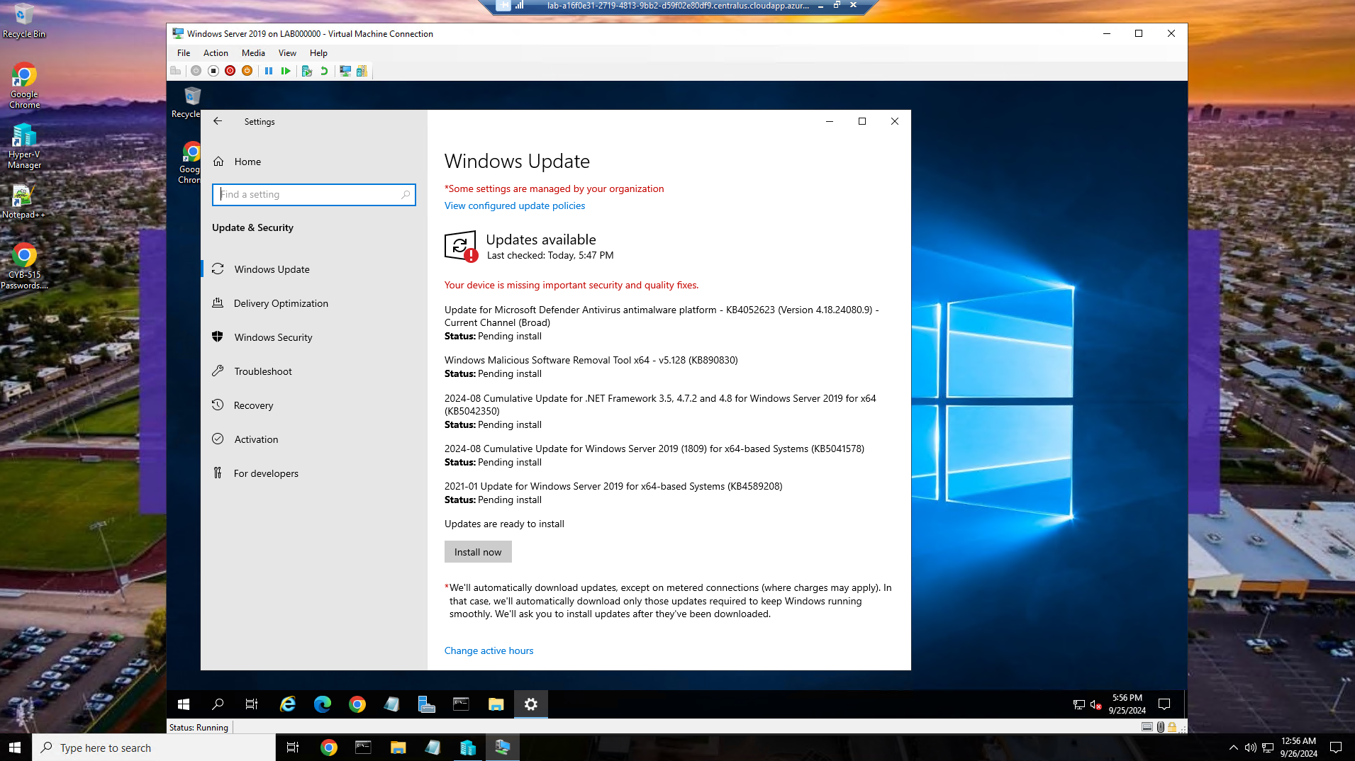

Screenshot of the Windows 2019 Server needing updates.

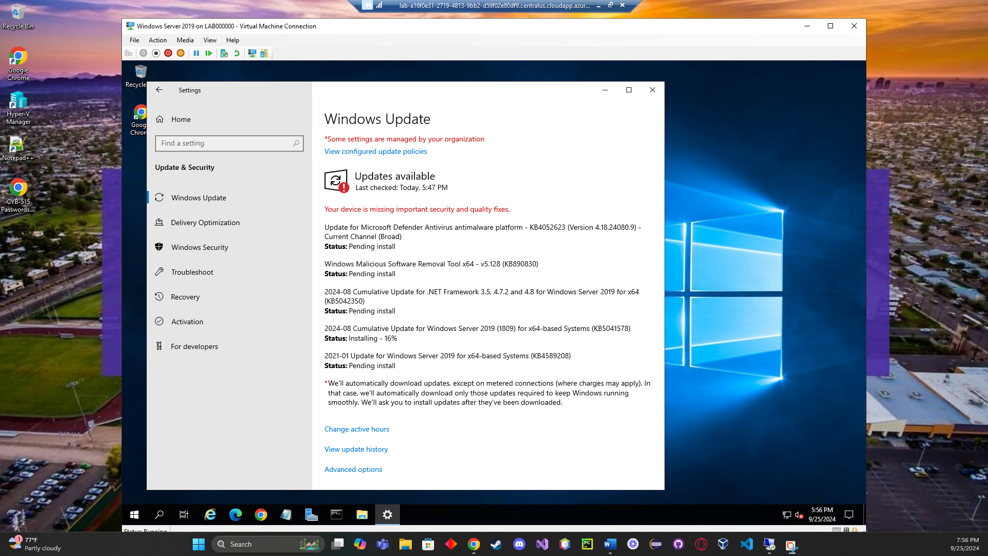

Screenshot of the updates installing.

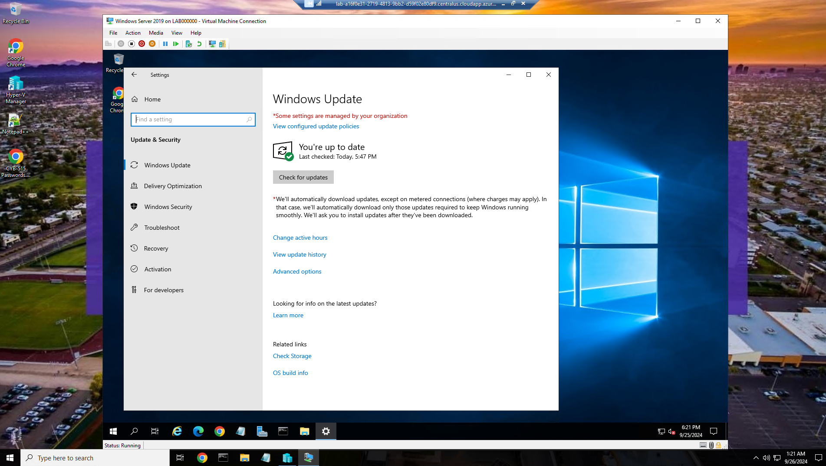

Screenshot after all updates were installed and server restarted.

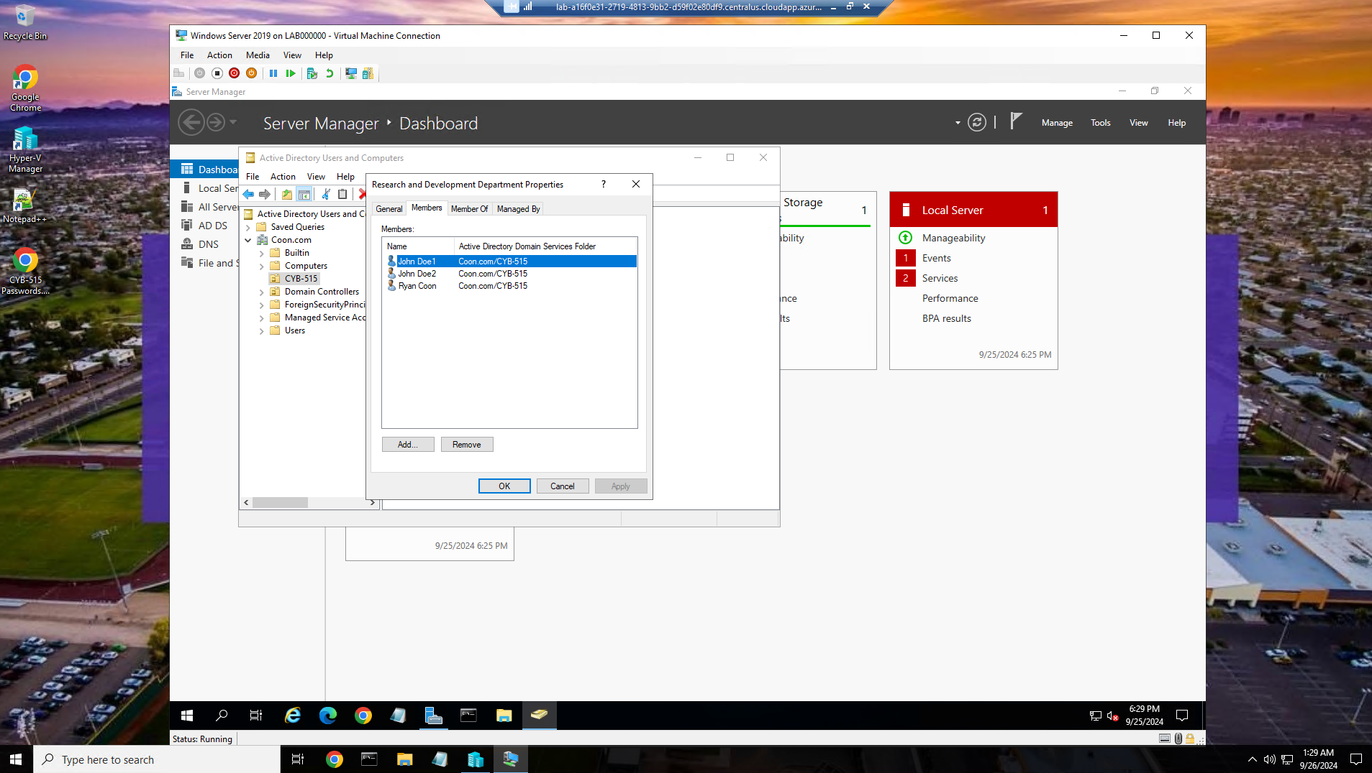

3 users added to the Research and Development group.

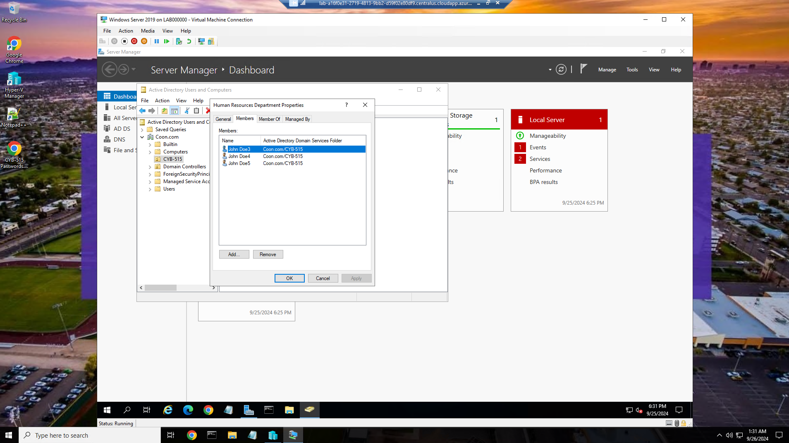

3 users added to the Human Resources group.

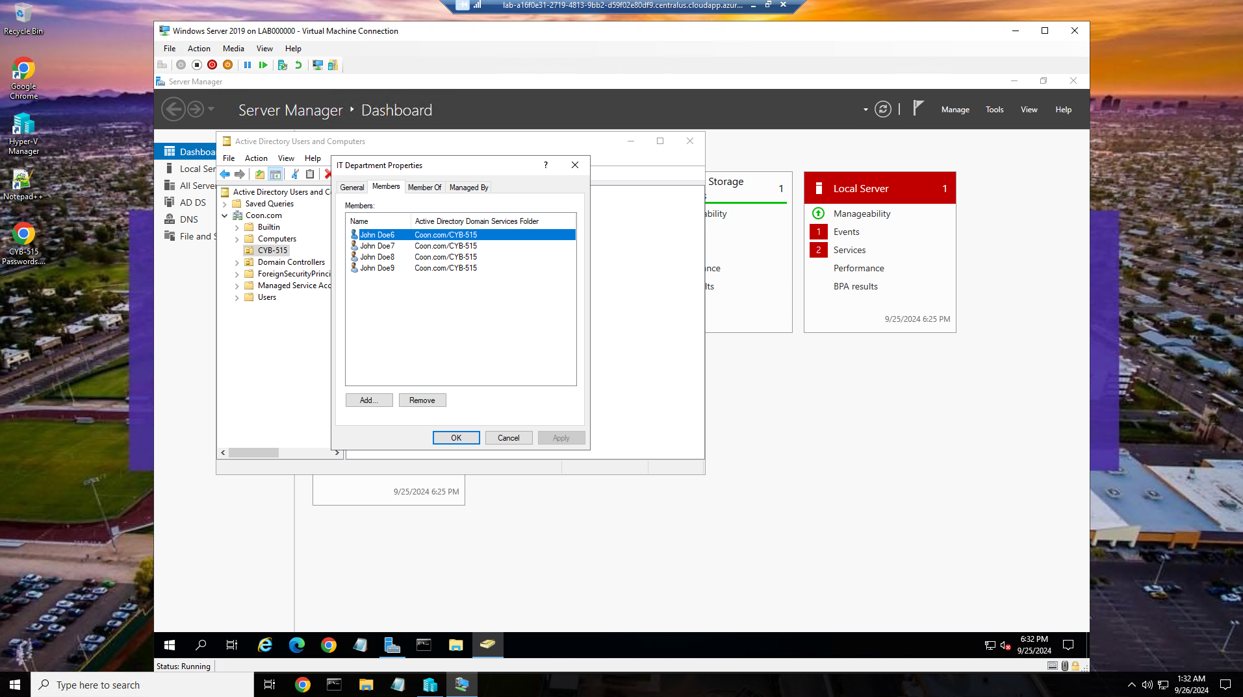

Remaining 4 users added to the IT Department group.

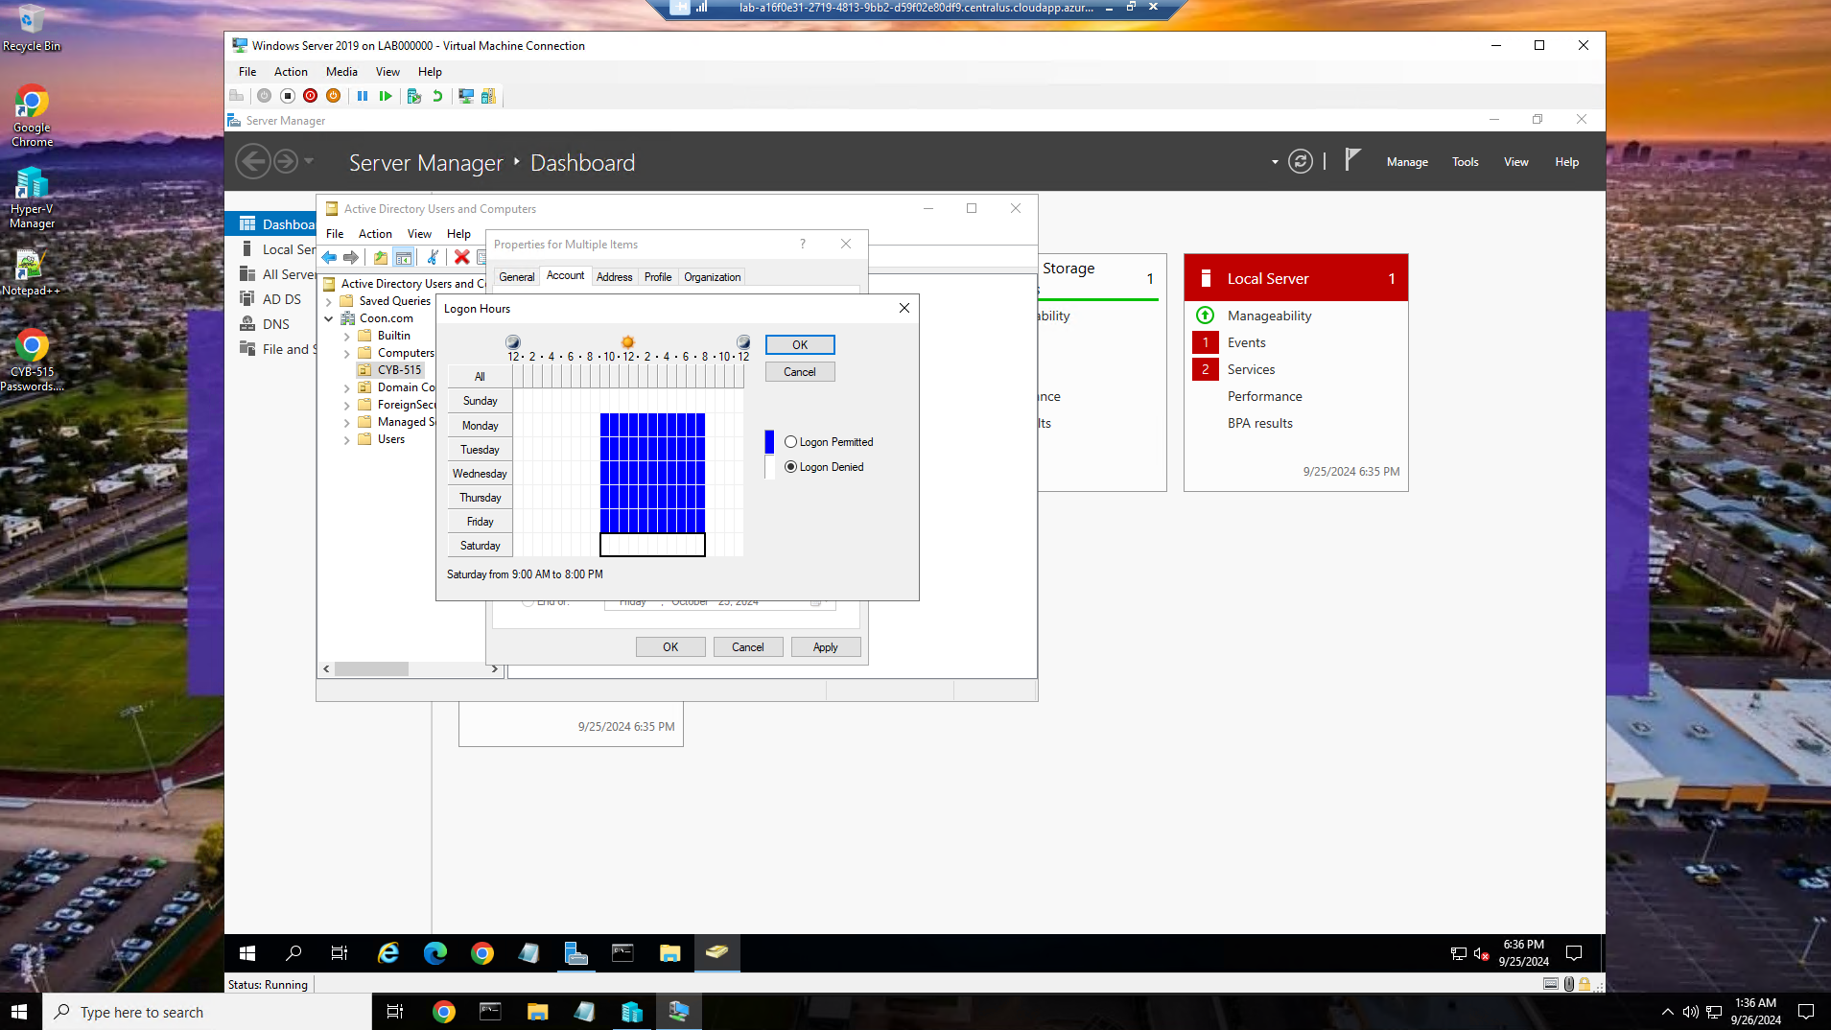

Members of the Research and Development group hours set to Monday – Friday from 9 am to 8 pm. Logon outside these days and or hours will not let them login.

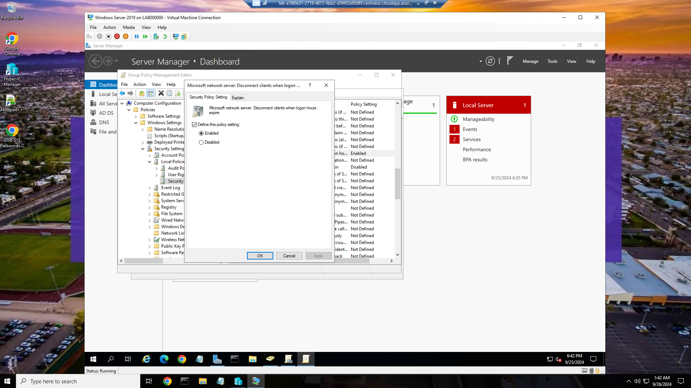

Enabled and pushed out a group policy to automatically log users off the system when their log-on hours expire.

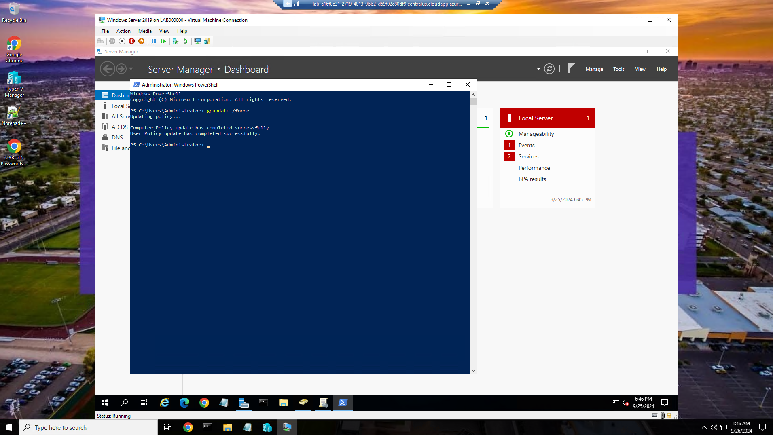

Showing the successful completion of the user policy force update.

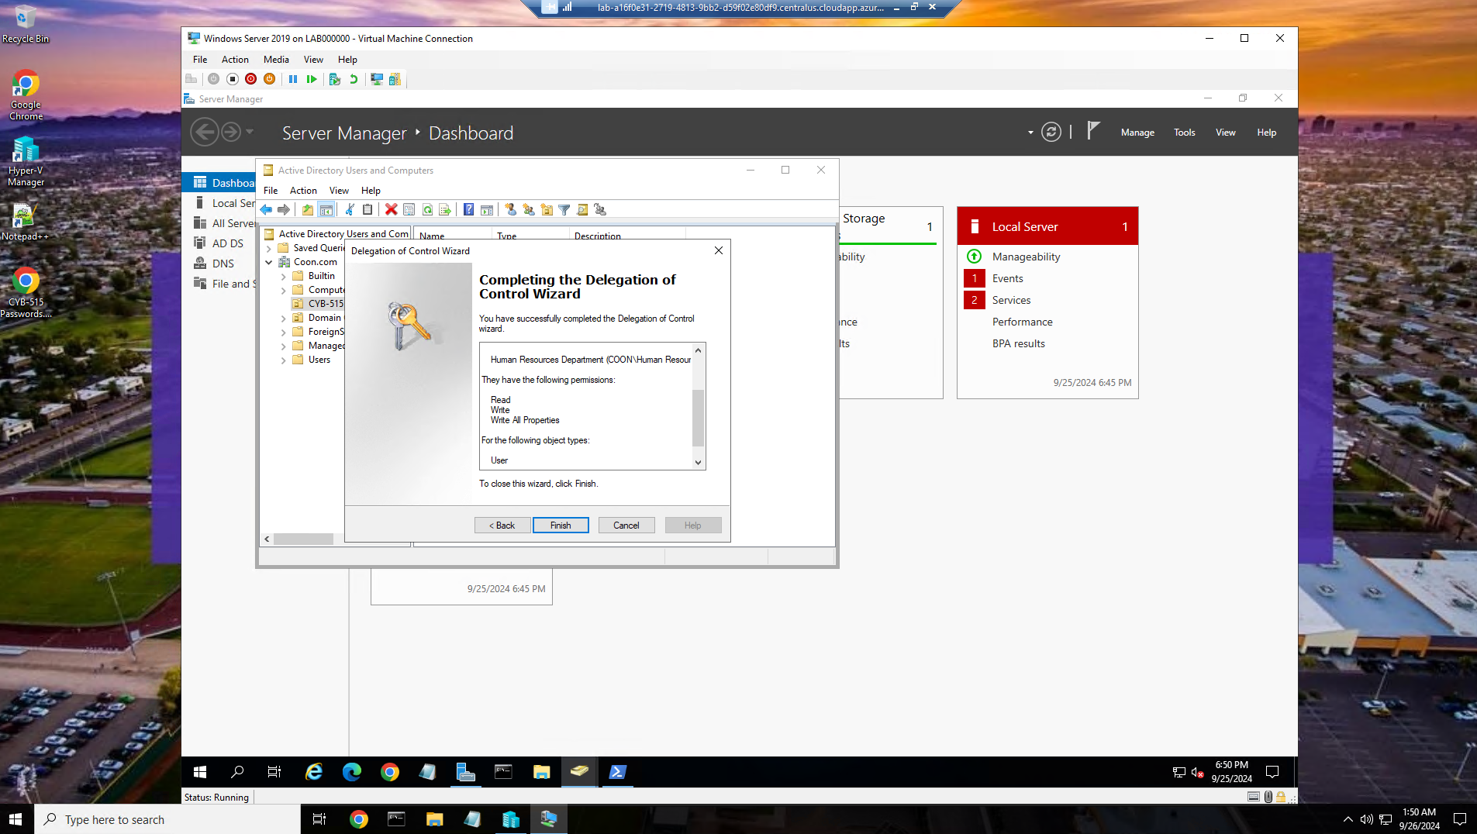

Applied the principle of least privilege to users in the Human Resources Department to allow users in the HR group the access to read and write access to all AD user account information.

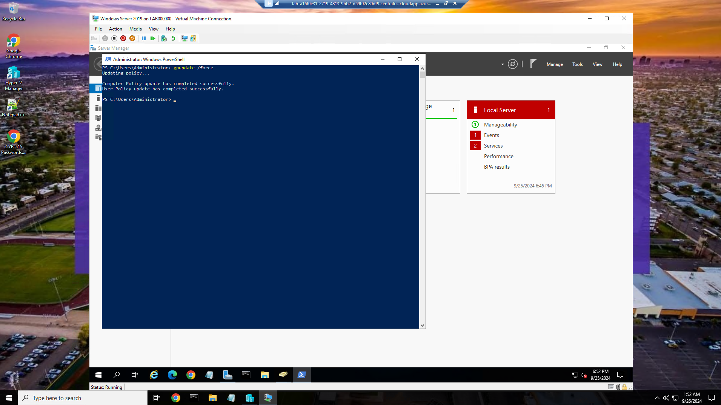

Successful completion of the policy update.

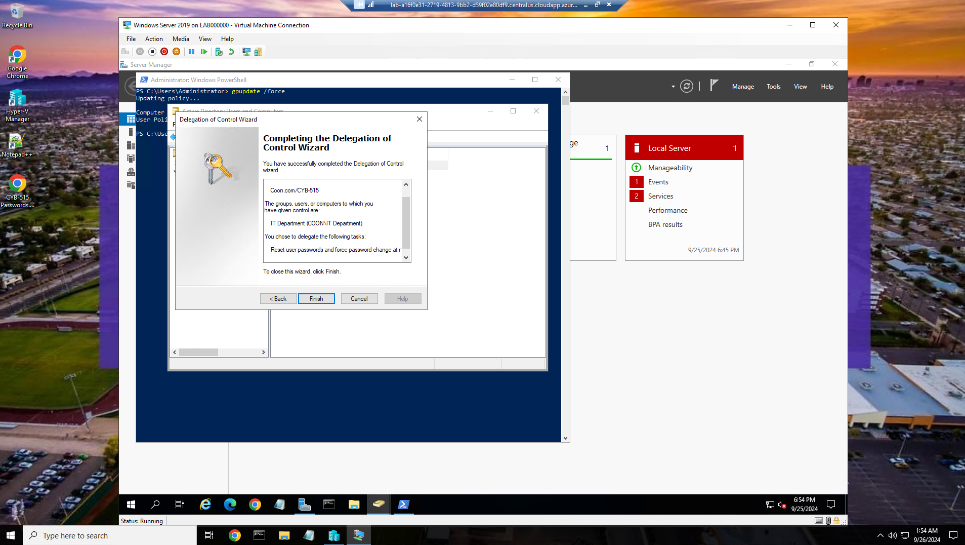

Applied the principle of least privilege to users in the IT Department group to allow IT users to reset passwords and force a password change at the next log-on for all AD user accounts.

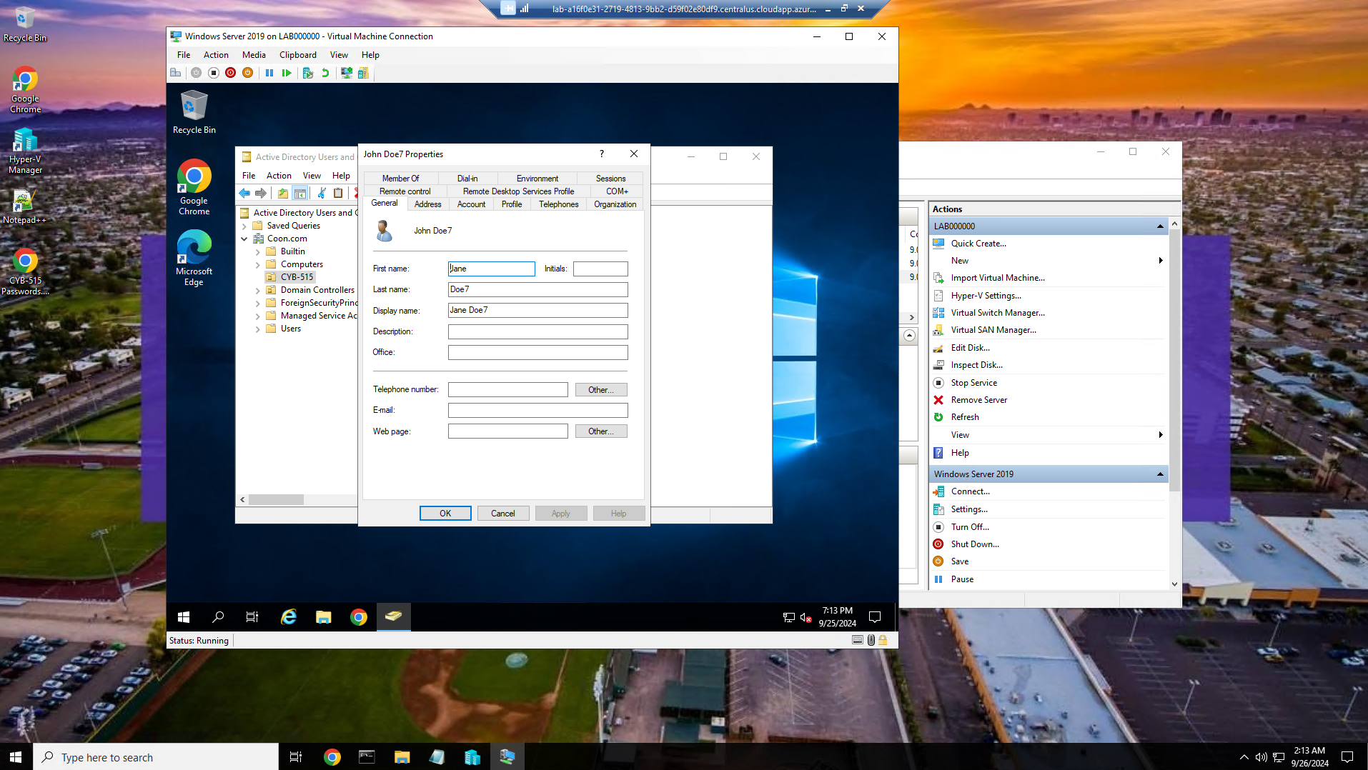

Logged in as an HR user, changed John Doe 7 to Jane Doe 7

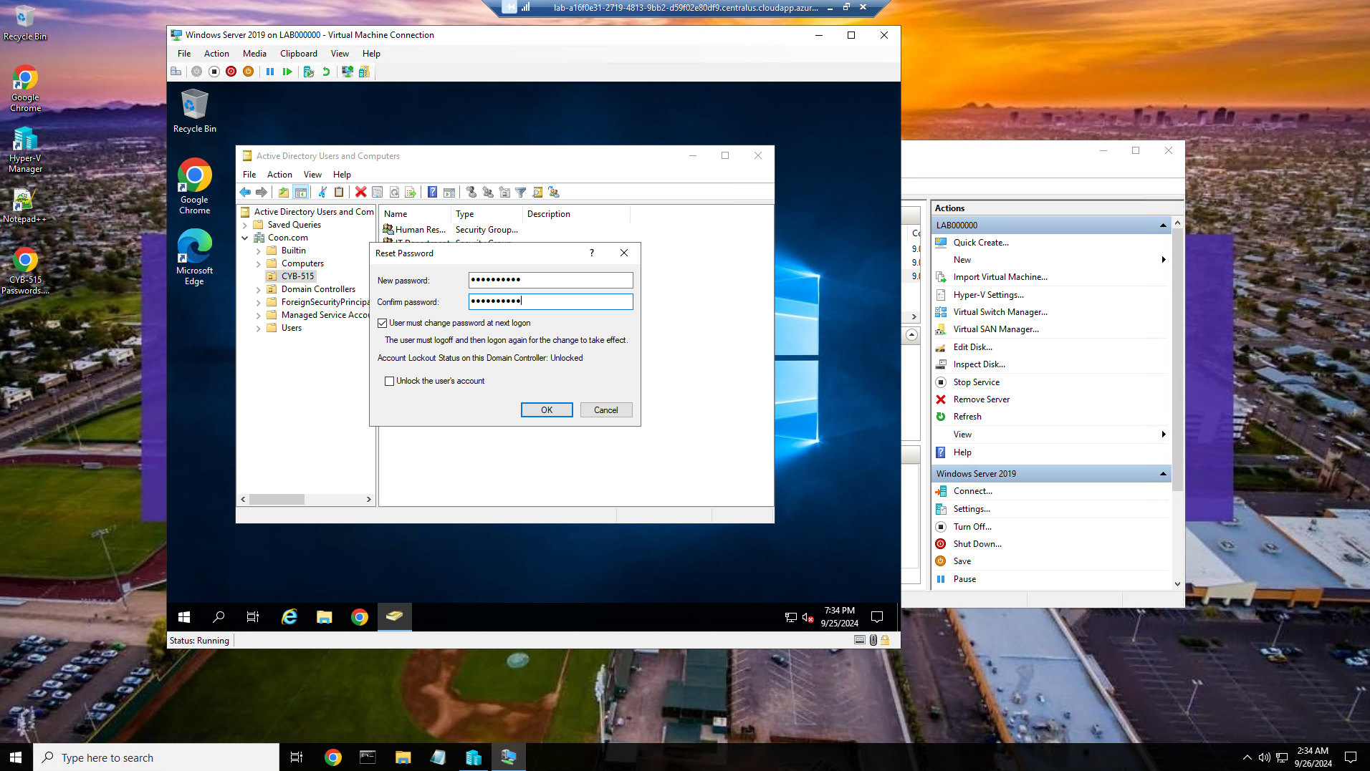

Logged in with an IT user account, changing the password to John Doe 7.

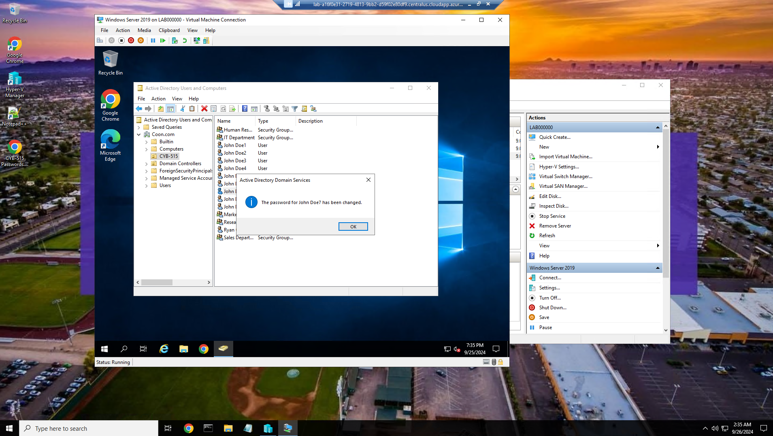

Notification of the successful password change for John Doe 7.

Part 2:

**Provide a brief explanation of what you accomplish when you install an operating system.**

An operating system (OS) is like the boss of your computer. It helps apps and hardware work together(Nagendra, 2024). When you install an operating system, you're essentially setting up the foundation for your computer to function. One can look at it as if they were building a house.

Laying the Foundation - The OS provides the core software that manages your hardware, allowing everything from your keyboard to your graphics card to work together.

Building the Walls - The OS creates the environment where your programs and applications can run.

Adding the Utilities - The OS comes with essential utilities like file management, network connectivity, and security features.

Connecting the Power - The OS acts as the intermediary between your hardware and software, ensuring they communicate properly and work together seamlessly.

**Explain why it is important to install patches and updates as an operating systems administrator.**

As an operating systems administrator, installing patches and updates is essential for maintaining the security, stability, compliance, functionality, and future compatibility of your operating system. It's a vital part of responsible system administration.

Security - Patches often address vulnerabilities that could be exploited by hackers. These vulnerabilities might allow attackers to gain unauthorized access to your systems, steal data, or even take control of your computers. Software and app updates often include security patches that address known vulnerabilities and protect your device from new threats(Why you should regularly install your software and app updates, nd).

Stability - Updates can improve the stability and performance of your operating system. They might fix bugs, enhance compatibility with new hardware or software, or optimize system resources.

Compliance - Many organizations now have regulatory requirements or insurance directives mandating a regular patching regime(Understanding OS Patching, nd). Failure to comply can lead to fines, penalties, and reputational damage.

Functionality - Updates can add new features and functionalities to your operating system, enhancing its capabilities and making it more useful.

**Explain the significance of configuring appropriate authentication group policies as part of managing system services and user accounts.**

Organizations commonly assign different authentication policies for full-time employees, contractors, and outside partners(Tang, 2021). Configuring appropriate authentication group policies is like setting up a sophisticated security system for your organization's network and user accounts. It's a crucial part of managing system services and user accounts because it enforces access control, strengthens security, enhances user experience, improves compliance, and reduces risk. Configuring authentication group policies is a fundamental aspect of secure system management. It ensures that only authorized users can access the resources they need, while protecting sensitive information from unauthorized access

**Explain the interaction between security and system usability, and the importance of minimizing the effects of security mechanisms.**

Security is aimed at making undesirable actions more difﬁcult while usability aims at making desirable ones easier for the user, it may also be true that improving one also improves the other(Kainda et al, 2010). The interaction between the two is like a balancing act, you need to find the right balance to make it work.

**The Interaction**

Security can hinder usability - Security measures like complex passwords, multi-factor authentication, and access restrictions can make it harder for users to access and use systems

Usability can weaken security -  If systems are too easy to use, they might be more vulnerable to attacks.

**The importance of minimizing the effects of security mechanisms**

Improved User Experience - Users are more likely to comply with security measures if they are easy to use and understand. This leads to a more positive user experience and greater adoption of security practices.

Increased Productivity - When security doesn't hinder usability, users can focus on their tasks without unnecessary delays or frustrations. This increases productivity and efficiency.

Reduced Security Risks - By making security measures more user-friendly, you can encourage users to follow them, which reduces the risk of security breaches and data loss.

**References:**

Kainda, R., Flechais, I., & Roscoe, A. W. (2010). Security and Usability: Analysis and Evaluation. 2010 International Conference on Availability, Reliability and Security. https://doi.org/10.1109/ares.2010.77

Nagendra. (2024, April 26). Code 360 by Coding Ninjas. Www.Naukri.com. https://www.naukri.com/code360/library/objectives-of-operating-system

Security and usability: How to find a good balance. (2018, December 18). Avatao. https://avatao.com/blog-security-usability-best-practices/

Security Versus Usability: What if You Didn’t Have to Choose? (2023). Archonsecure.com. https://www.archonsecure.com/blog/security-and-usability-what-if-you-didnt-have-to-choose#:~:text=For%20as%20long%20as%20cybersecurity

Tang, S. (2021, March 19). Benefits of multiple authentication policies. Work Life by Atlassian. https://www.atlassian.com/blog/access/benefits-of-multiple-authentication-policies

Understanding OS Patching | The What and Why | SuperOps.ai. (n.d.). Superops.com. https://superops.com/patch-management/os-patching#:~:text=Keeping%20your%20systems

What is user authentication, and why is it important? | NordVPN. (2023, August 20). Nordvpn.com. https://nordvpn.com/blog/what-is-user-authentication/#:~:text=User%20authentication%20helps%20to%20identify

Why you should regularly install your software and app updates. (2023). Australianmutual.bank. https://australianmutual.bank/news-blog/articles/why_you_should_regularly_install_your_software_and_app_updates/#:~:text=Installing%20updates%20can%20improve%20the%20overall%20performance